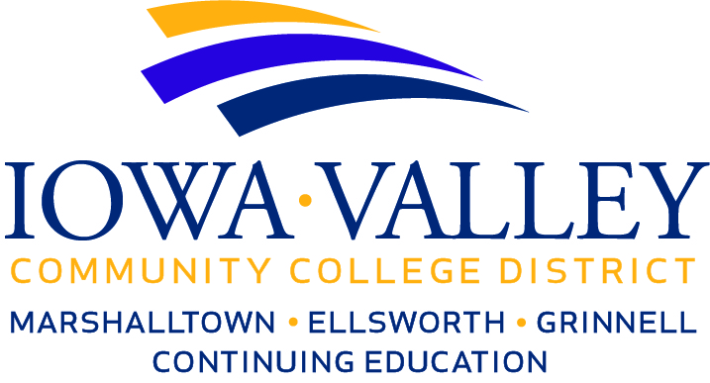**Meeting with Superintendents**

**Wednesday, November 29, 2017**

**Iowa Valley Continuing Education – Building #3**

**Rooms 612-614**

**Marshalltown, Iowa 50158**

**8:30 A.M. Breakfast – 9:00 A.M. Meeting**

AGENDA

8:30 – 9:00 A.M. Breakfast

9:00 – 9:10 A.M. Welcome and Introductions

9:10 – 9:15 A.M. Review agenda

9:15 – 10:00 A.M. Future Ready Iowa Recommendations

10:00 – 10:15 A.M. Break

10:15 – 10:45 A.M. HF 2392 - Regional Planning Partnership Progress

10:45 – 11:15 A.M. Education Services Contracts for FY19 – Study Committee Progress/Recommendations

11:15 – 11:30 A.M. Updates on IVCCD and School Districts’ Bond Referendums

11:30 A.M. – 12:00 Noon Miscellaneous Topics for Discussion

12:00 Noon Adjournment